  

**Sanchay Sathi Jannatun is increasing saving practices among rural women**

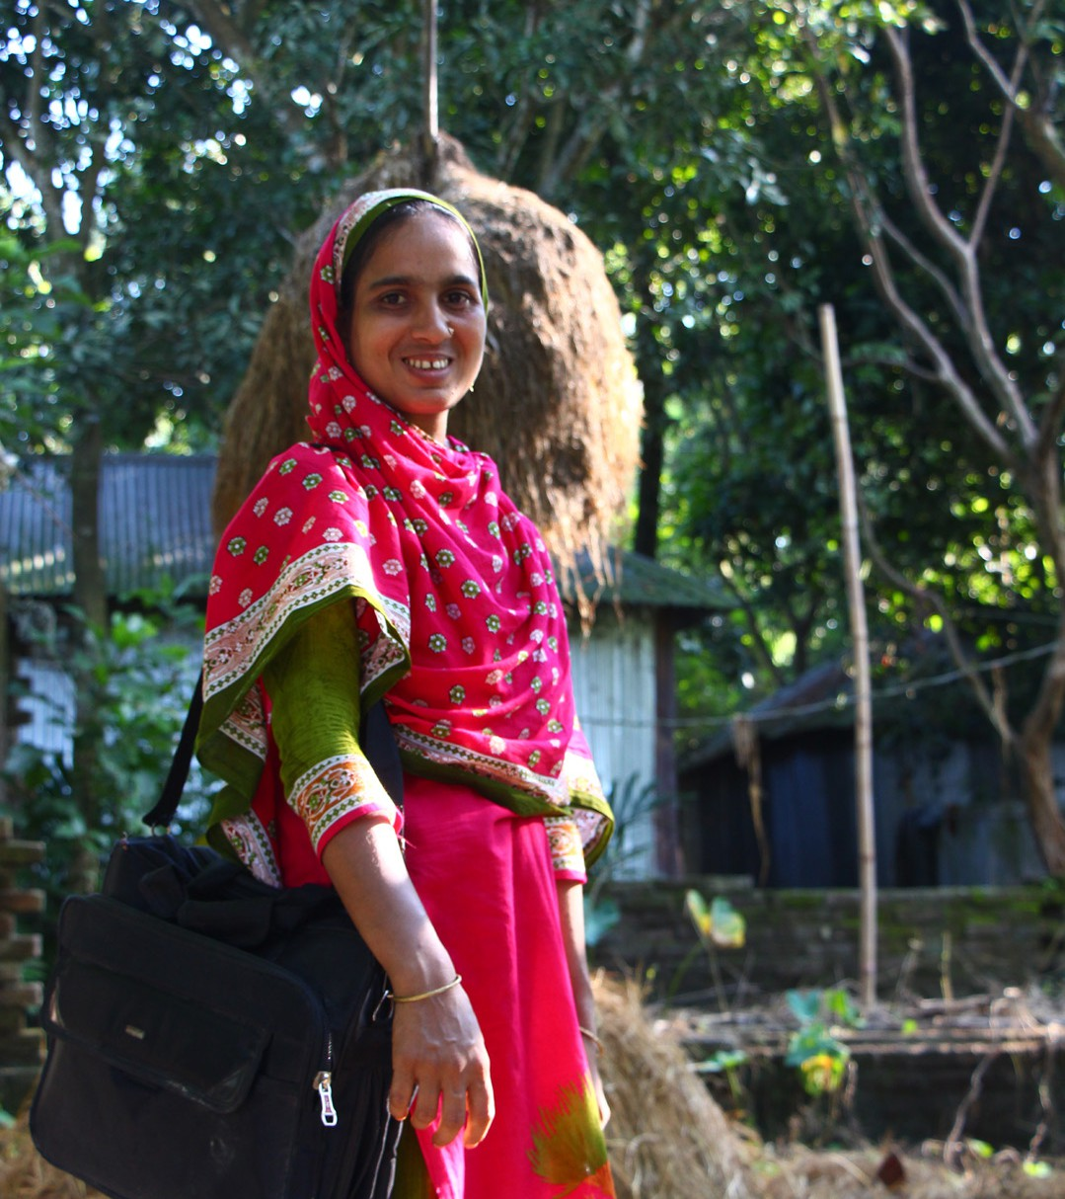Jannatun Begum has worked as a Sanchay Sathi in Kurigram, Bangladesh, for four years. She oversees and maintains the accounts of ten Village Savings and Loans Association [(VSLAs)](https://shouhardo.carebangladesh.org/wp-content/uploads/2022/08/Savings-practices-catapulting-rural-women-toward-economic-empowerment-1.pdf) and organizes twenty VSLA meetings per month.

Jannatun received five days of training on financial practices and empowerment

from CARE’s SHOUHARDO III program in 2019. Upon receiving the training, she formed ten VSLAs within less than a year. Jannatun shared her success factor:

**“After forming one VSLA, I realized I could make it my occupation. Through this, I could help other poor women in**

**my village by promoting savings practice among them.”**

*“Initially, the first VSLA members helped me to form a few more groups, and then more people expressed their interest in forming new groups. It was just ‘word of mouth’ and my reputation.This is how I formed 10 VSLAs in such a short time.”*

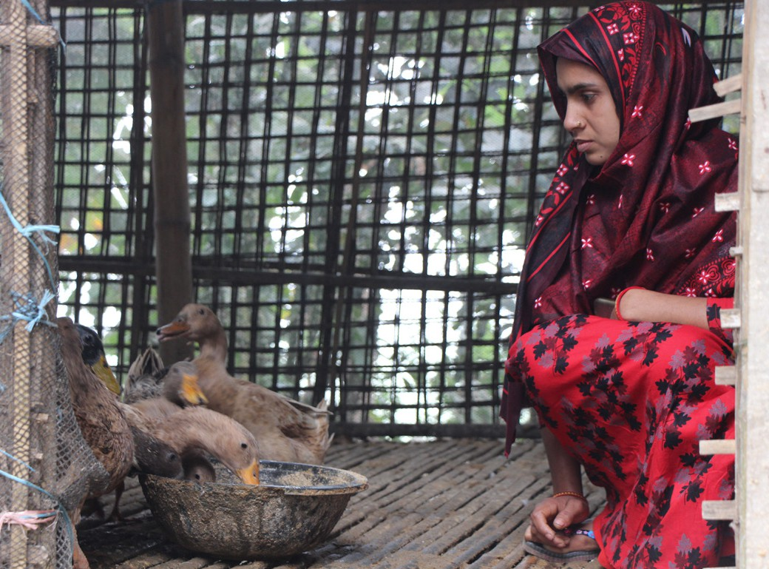Over the last three years, Jannatun has earned more than BDT 30,000 (USD

$ 283.9) from her ten VSLAs (in both share and service charges) and has invested these earnings into establishing a duck farm. She originally purchased 125 ducklings, and after rearing them, she sold 75 matured ducks for approximately BDT 33,000 (USD $ 312.3). Now, she sells duck eggs at the market and earns about BDT 3,000 (USD $28.57) as a regular monthly income.

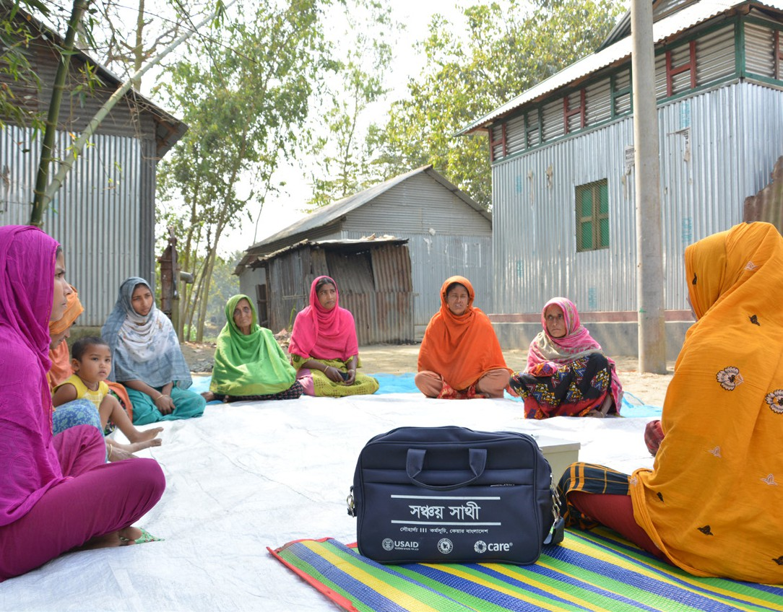Beyond the monetary compensation and benefits generated from livelihood diversification, Jannatun receives social recognition for her work as a Sanchay Sathi. She uses her work to form meaningful relationships with the Union Parishad and government offices at the district level.

These linkages have increased her community members’ access to a wide variety of social safety net services such as old age allowances, widow allowances, seeds, and vaccines for poultry and livestock.

**“Jannatun helps other women to save money for the future as well she earns money with dignity. She is an example to us.”**

**-- VSLA group members of Jannatun’s group**

*“This document is made possible by the generous support of the American people through the United States Agency for International Development (USAID).The Contents are the responsibility of CARE Bangladesh and do not necessarily reflect the views of USAID or the United States.”*